PROTOCOL

Setting up an API-20E strip test.

1. Place a small amount of water in the incubation tray (under the API strip itself) to provide humidity during incubation.

2. Prepare a milky (visibly turbid) suspension of your organism in sterile water.

3. Use a plastic sterile pipette to half-fill test wells of your API strip with the above suspension (Holding the strip at a slight angle as well as letting the end of the pipette touch the side of a well will make this easier. Make sure all air bubbles are eliminated).

4. When there is a line under a well (ADH, LDC, ODC, H2S, URE), add sterile mineral oil to completely fill in the well.

5. When there is a box under a well (CIT, VP and GEL), add some more bacterial suspension to completely fill in the well.

6. Place the plastic lid back on and label the tray with your name, date and organism code.

7. Incubate at 37°C for 24 hours.

After incubation:

1. Add one drop of reagent TDA (10% ferric chloride) to the well labelled as TDA.

2. Add one drop of reagent IND (Kovacs’ reagent) to the well labelled as IND.

3. Add one drop of reagent VP1 (40% KOH), THEN add one drop of reagent VP2 (6% alpha-naphtol) to the well labelled as VP.

4. Wait for 10 min to observe colour changes.

5. Read the colour reactions obtained for each well, and record your results (as positive or negative) for each test following the interpretation guide.

6. Using the BacDive API test finder, try to determine the identity of your unknown based on your results.

TEST RESULTS – API-20E
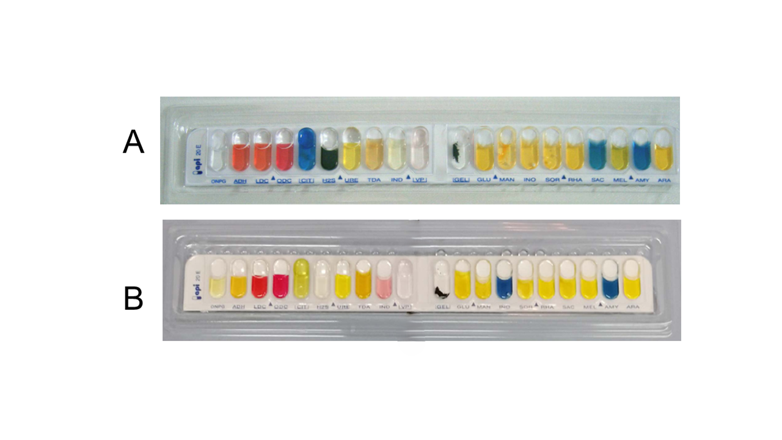

A = even; B = odd

INTERPRETATION TABLE – API strips

Table 1: scoring test and reaction results
Scoring Test | Reaction tested | Negative | Doubtful | Positive | Strong Positive
ONPG | β-galactosidase | colourless | faint yellow | pale yellow | Yellow
ADH  LDC  ODC | Arginine dihydrolase  Lysine decarboxylase  Ornithine decarboxylase | yellow | yellow/orange | orange/red | red
CIT | Citrate utilisation | yellow | pale green | Blue | deep blue
H₂S  (deposit) | Sulphide production | no deposit | trace of black | Black | heavy black deposit
URE | Urease | yellow | yellow/orange | orange/red | Red
TDA (add  reagent) | Tryptophan deaminase | yellow | yellow/brown | Brown | dark brown
IND (add  reagent) | Indole production | yellow | pale pink ring | pink ring | red ring
VP (add  reagent) | Voges-Proskauer reaction | colourless | pale pink | pink/red | Red
GEL | Gelatinase | pigment does not dissolve | pigment dissolves slightly | Grey | Black
GLU  MAN  INO  SOR  RHA  SAC  MEL  AMY  ARA | Glucose fermentation  Mannose fermentation  Inositol fermentation  Sorbose fermentation  Rhamnose fermentation  Sucrose fermentation  Mellibiose fermentation  Amygdalin fermentation  Arabinose fermentation | blue | blue/green | Yellow | strong yellow
OXI | Oxidase | pale brown |  | dark brown | purple

