Writing exercise S06: Experimental Narratives

Dr. Morgan Feeney, AY 2024-25

You will want to describe your experiments in a logical way:
- Aim (what you intended to do/show with the experiment)
- Method (what the experiment was, how you performed it)
- Results (what you showed/discovered)
- Significance (what the results mean, a logical transition to the next experiment)

Examples from a published paper¹: (aim, method, results, significance highlighted)
To gain insight into the cellular processes controlled by c-di-GMP in streptomycetes, we overexpressed either the active DGC CdgB from S. coelicolor (Tran et al., 2011) or the active PDE YhjH from E. coli (Pesavento et al., 2008). Strikingly, overexpression of both CdgB and YhjH blocked the generation of aerial mycelium by S. venezuelae (Figure 1B). However, scanning electron micrographs (SEMs) revealed that, whereas overexpression of CdgB blocked development, resulting in a classical bald phenotype, overexpression of the PDE YhjH in fact promoted sporulation, but the colonies appeared bald to the naked eye because aerial mycelium formation had been bypassed (Figure 1C). As judged by heat resistance, the spores made by the YhjH overexpression strain were as robust as those of the wildtype (WT) (Figure S1A available online). Moreover, overexpression of catalytically inactive versions of YhjH or CdgB had no effect on S. venezuelae development (Figure S1B). These data suggest that intracellular levels of c-di-GMP influence the timing of development. In particular, they suggest that increased c-di-GMP levels delay differentiation, arresting the colonies in the vegetative growth stage, whereas decreased levels of the second messenger accelerate development, favoring sporulation.
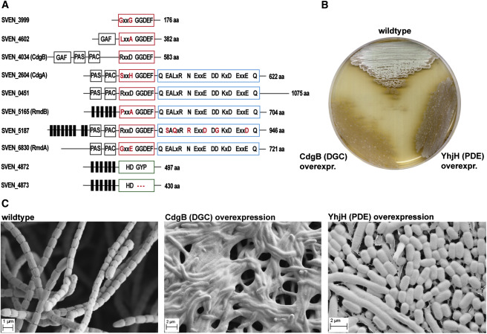
Figure 1. c-di-GMP Levels Affect S. venezuelae Development
(A) Domain organization of predicted active c-di-GMP-metabolizing proteins in S. venezuelae. GGDEF domains are shown as red boxes. Amino acids different from the conserved product inhibition site (RxxD) are shown in red. Noncanonical residues of the EAL domains (blue box) and HD-GYP domains (green box) are highlighted in red. Predicted transmembrane helices are shown as black bars, and N-terminal GAF, PAS, and PAC signaling domains are boxed in black.
(B) Overexpression of CdgB (a DGC from S. coelicolor) or YhjH (a PDE from E. coli) from the ermEp∗ promoter in S. venezuelae results in loss of aerial mycelium formation.
(C) SEMs reveal that while CdgB overexpression blocks development (giving rise to a classic “bald” phenotype; middle), YhjH overexpression (right) induces precocious hypersporulation without formation of aerial hyphae. Spore-bearing aerial hyphae of the WT are shown for comparison (left). Cells were grown on maltose-yeast extract-malt extract (MYM) agar for four days at 30°C prior to imaging.

Exercise A.
Read each example and identify the aim, method, result, and significance parts of the author’s description. Can you improve the logical flow of the narrative?
Sample 6.1 ²
As first reported by Li⁸ and Fix et al,⁹ we found that concurrent expression of RexA and RexB in E. coli sensitizes the cells to UV irradiation (Fig. 2A). In strain LT732, the RexA, RexB, and the CI857 repressor proteins are expressed from the bacterial chromosome in single copy from the phage P_{RM} and P_{LIT} promoters (Fig. 1B), in the absence of any other phage functions. Strain LT1964 is identical to strain LT732 except for a mutation in the −10 region of the P_{LIT} promoter, thereby reducing the level of RexB relative to RexA in LT1964. This change in the ratio of the RexB and RexA proteins increases LT1964 sensitivity to UV-mediated DNA damage (Fig. 2A). Note that strains with null mutations in either or both rex genes have UV survival curves such as those of wild type E. coli (Fig. 2B). Thus, it is the relative change in RexA and RexB expression levels that causes increased UV sensitivity.

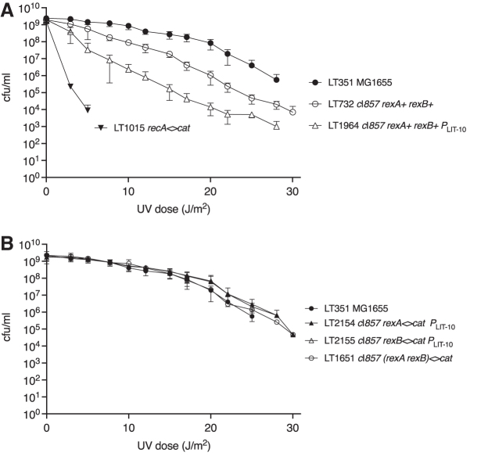
FIG. 2. λ RexA and RexB function sensitizes Escherichia coli to UV irradiation, and λ Ren rescues UV sensitivity. UV survival curves were generated as described in the Materials and Methods section. The phage λ genes present in each strain are indicated in the figure legend. For all strains except those lacking any phage DNA, the phage genes are inserted in single copy at the E. coli lac operon⁵ and the phage cI857 repressor gene is present. The number of independent experiments (n) is 3 unless otherwise indicated, and the SD is indicated by vertical bars. Strain LT351 is MG1655 (●), which provides a wildtype control of survival after UV exposure, and is shown in all graphs (n = 4). (A) Expression of phage λ rexA and rexB genes increases UV sensitivity of E. coli. Strain LT732 (○) bears the λ immunity region with cI857, rexA, rexB, and T_{IMM} (n = 4) as shown in Figure 1B. Strain LT1964 (▵) has the same DNA as LT732 but with a mutation in the −10 region of the P_{LIT} promoter, P_{LIT-10}. Survival of a recA mutant, strain LT1015, is shown for comparison (▼). (B) Strains lacking rexA and/or rexB have UV resistance like that of MG1655. The individual rex mutants LT2154 rexA<>cat P_{LIT-10} (▼) and LT2155 rexB<>cat P_{LIT-10} (▵) contain the P_{LIT-10} mutation. The doubly rex mutant strain, LT1651 cI857 (rexA rexB)<>cat (○), expresses only the phage cI857 gene.
Suggested improvements?

Sample 6.2 ³
In the genome of E. coli, the hiuH gene is located 109 bp upstream of msrP and 1,114 bp upstream of msrQ (Fig. 1A). The expression of hiuH, msrP, and msrQ has been reported to be under the control of the HprSR two-component system (13, 16), with an HprR box located upstream of hiuH (87 to 70 bp before the hiuH start codon). These observations suggest that hiuH, msrP, and msrQ might belong to the same operon. This hypothesis was explored further by reverse transcription-PCR (RT-PCR) using converging pairs of primers located within each of the three genes: after RNA reverse transcription, PCR amplifications were observed between hiuH and msrP and between msrP and msrQ, showing a tricistronic organization (Fig. 1B). As positive and negative controls, we used chromosomal DNA and total RNA, respectively, as templates for PCR amplifications with the same pairs of primers. Together, these experiments strongly suggest that hiuH, msrP, and msrQ are part of the same operon.
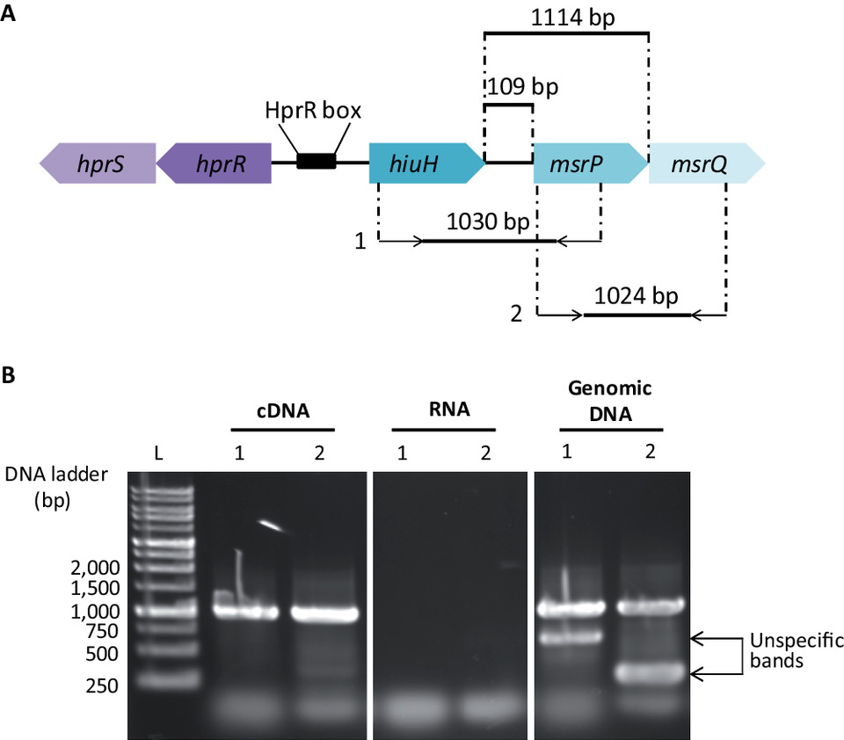
FIG 1 Genetic organization of hiuH, msrP, and msrQ in Escherichia coli K-12. (A) Schematic representation of the hprRS operon, hiuH, msrP, and msrQ genes. In the E. coli genome, hiuH, msrP, and msrQ are adjacent: they are located in proximity to the hprR-hprS operon. The intergenic region between hiuH and hprR contains the HprR box (CATTACAAAATTGTAATG) (15). Primer positions used for the following experiments are indicated on the diagram: the first set of primers amplify the region of 1,030 bp between hiuH and msrP (1). The second set amplify the region of 1,024 bp between msrP and msrQ (2). (B) RT-PCR analysis of hiuH, msrP, and msrQ. E. coli cells MG1655 (WT) were cultured in the presence of 2 mM HOCl in LB medium. Total RNA was extracted and retrotranscribed into cDNA. PCRs were carried out on total extracted RNA, chromosomal DNA, on cDNA using the primers depicted in panel A.

Suggested improvements?

Sample 6.3 ⁴

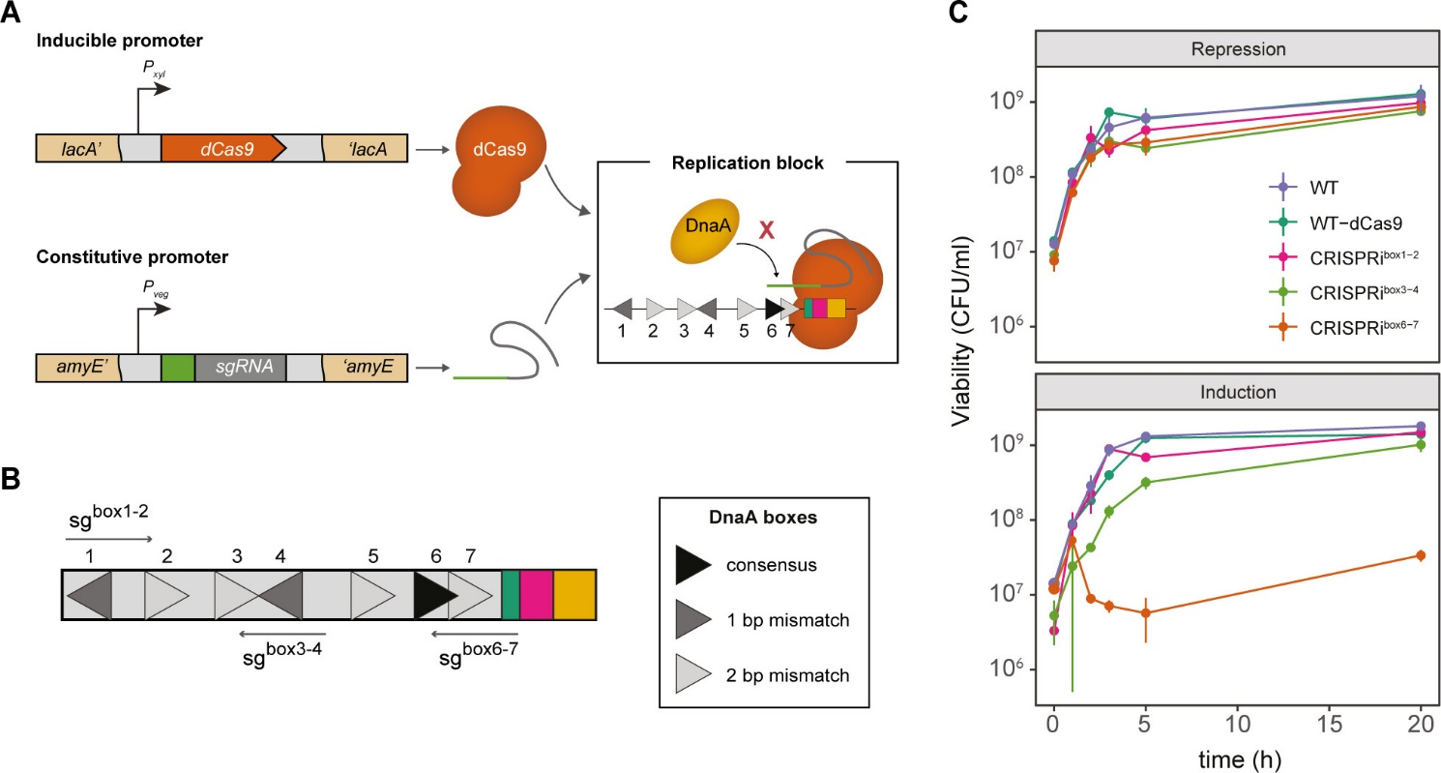
Fig 1 CRISPRi targeting the DnaA boxes 6 and 7 inhibits cell proliferation. (A) B. subtilis carrying a xylose-inducible dCas9 (orange) is directed to specific DNA targets by constitutively expressed sgRNAs (green) under the control of the P_{veg} promoter. The dCas9-sgRNA complex blocks the binding of DnaA (yellow) to the DnaA boxes (triangles). dcas9 was stably integrated into the lacA locus (EC3137), and the sgRNAs were integrated into the amyE locus [CRISPRi^{box1–2} (EC3146), CRISPRi^{box3–4} (EC3149), CRISPRi^{box6–7} (EC3147)]. (B) DnaA boxes from B. subtilis and the selected sgRNA targets. Other elements of the oriC are shown: DnaA trios (green), DnaD-binding sites (fuchsia), and the AT-rich region (yellow). (C) When induced at the early exponential growth phase, the CRISPRi^{box6–7} strain (EC3147) does not resume growth. Viability of cells (colony forming units [CFU] per milliliter) grown with glucose (dCas9 induction repression) or with xylose (dCas9 induction). The data shown are the mean of three biological replicates; error bars represent standard deviations from the mean.
A previous study characterized the critical role of DnaA boxes 6 and 7 on the oriC of B. subtilis in orchestrating DNA unwinding and replication initiation (16). We therefore hypothesized that replication initiation could be blocked by inducing dCas9 expression in the presence of single guide RNAs (sgRNAs) specifically designed to target the inactivated nuclease to these boxes and thereby hinder DnaA binding (23) (Fig. 1A). To this end, we constructed B. subtilis strains carrying a xylose-inducible dCas9 as well as constitutively expressed sgRNA^{box6–7} designed to target DnaA boxes 6 and 7. In addition, strains encoding sgRNAs designed to target DnaA boxes 1 and 2 or 3 and 4 (sgRNA^{box1–2} and sgRNA^{box3–4}, respectively) were constructed as controls (Fig. 1B; Table S1) (16). This system allows conditional expression of dCas9 in the presence of xylose and tight repression when glucose is available.
To assess the impact of this blockade on replication initiation, we examined cell growth during the early logarithmic phase under dCas9 induction or repression conditions. Cells with dCas9 in the absence of sgRNA [wild-type (WT)-dCas9] exhibited normal growth behavior, indicating that dCas9 expression alone does not affect bacterial proliferation (Fig. 1C). Furthermore, cultures repressed by glucose, containing either sgRNA^{box1–2}, sgRNA^{box3–4}, or sgRNA^{box6–7} showed subtle growth variations compared with the control, while inducing dCas9 with sgRNA^{box6-7} led to a significant decrease in colony forming units (CFU) per milliliter after 3 h compared to the WT (Fig. 1C). Notably, targeting adjacent boxes by inducing the CRISPRi system did not inhibit growth (Fig. 1C). This indicates specific competition between DnaA and dCas9 for binding to DnaA boxes 6 and 7.
The formation of the dCas9-sgRNA^{box6–7} complex could specifically block the formation of DnaA filaments, preventing the opening of the replication bubble associated with initiation. These results confirm the high specificity of DnaA binding to boxes 6 and 7 and demonstrate the potential of the CRISPRi system to modulate critical steps in replication initiation, as previously reported (16).
Suggested improvements?

Exercise B.

- How would you write a results section for the results shown in the following figures⁵?
- Compare your description with the authors’.

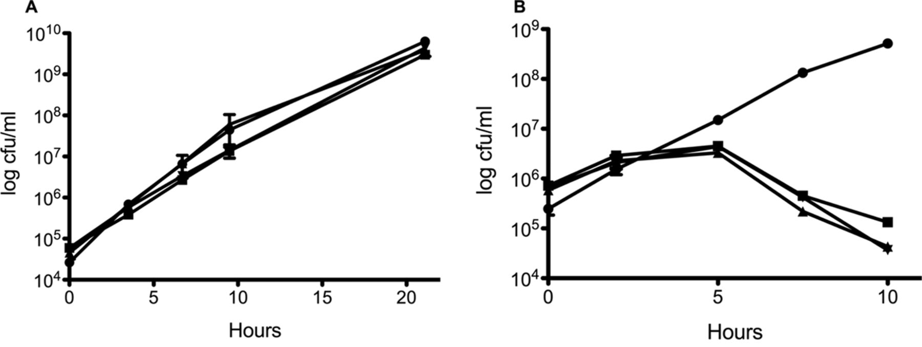
FIG 1 The DSB pathway is essential under anaerobic conditions. Log-phase aerobic cultures were diluted into M63glu and grown at 37°C aerobically (A), M63glu with 40 mM nitrate and grown at 37°C in an anaerobic chamber (B)….Samples were taken over time, serially diluted in LB, and plated to LB aerobically. After overnight incubation at 37°C, CFU were enumerated. ●, WT; ■, ΔdsbA mutant; ▲, ΔdsbB mutant; ▼, ΔdsbAB mutant. Growth curves were performed in triplicate and are plotted ± standard error of the mean (SEM). [Reproduced from Meehan et al]

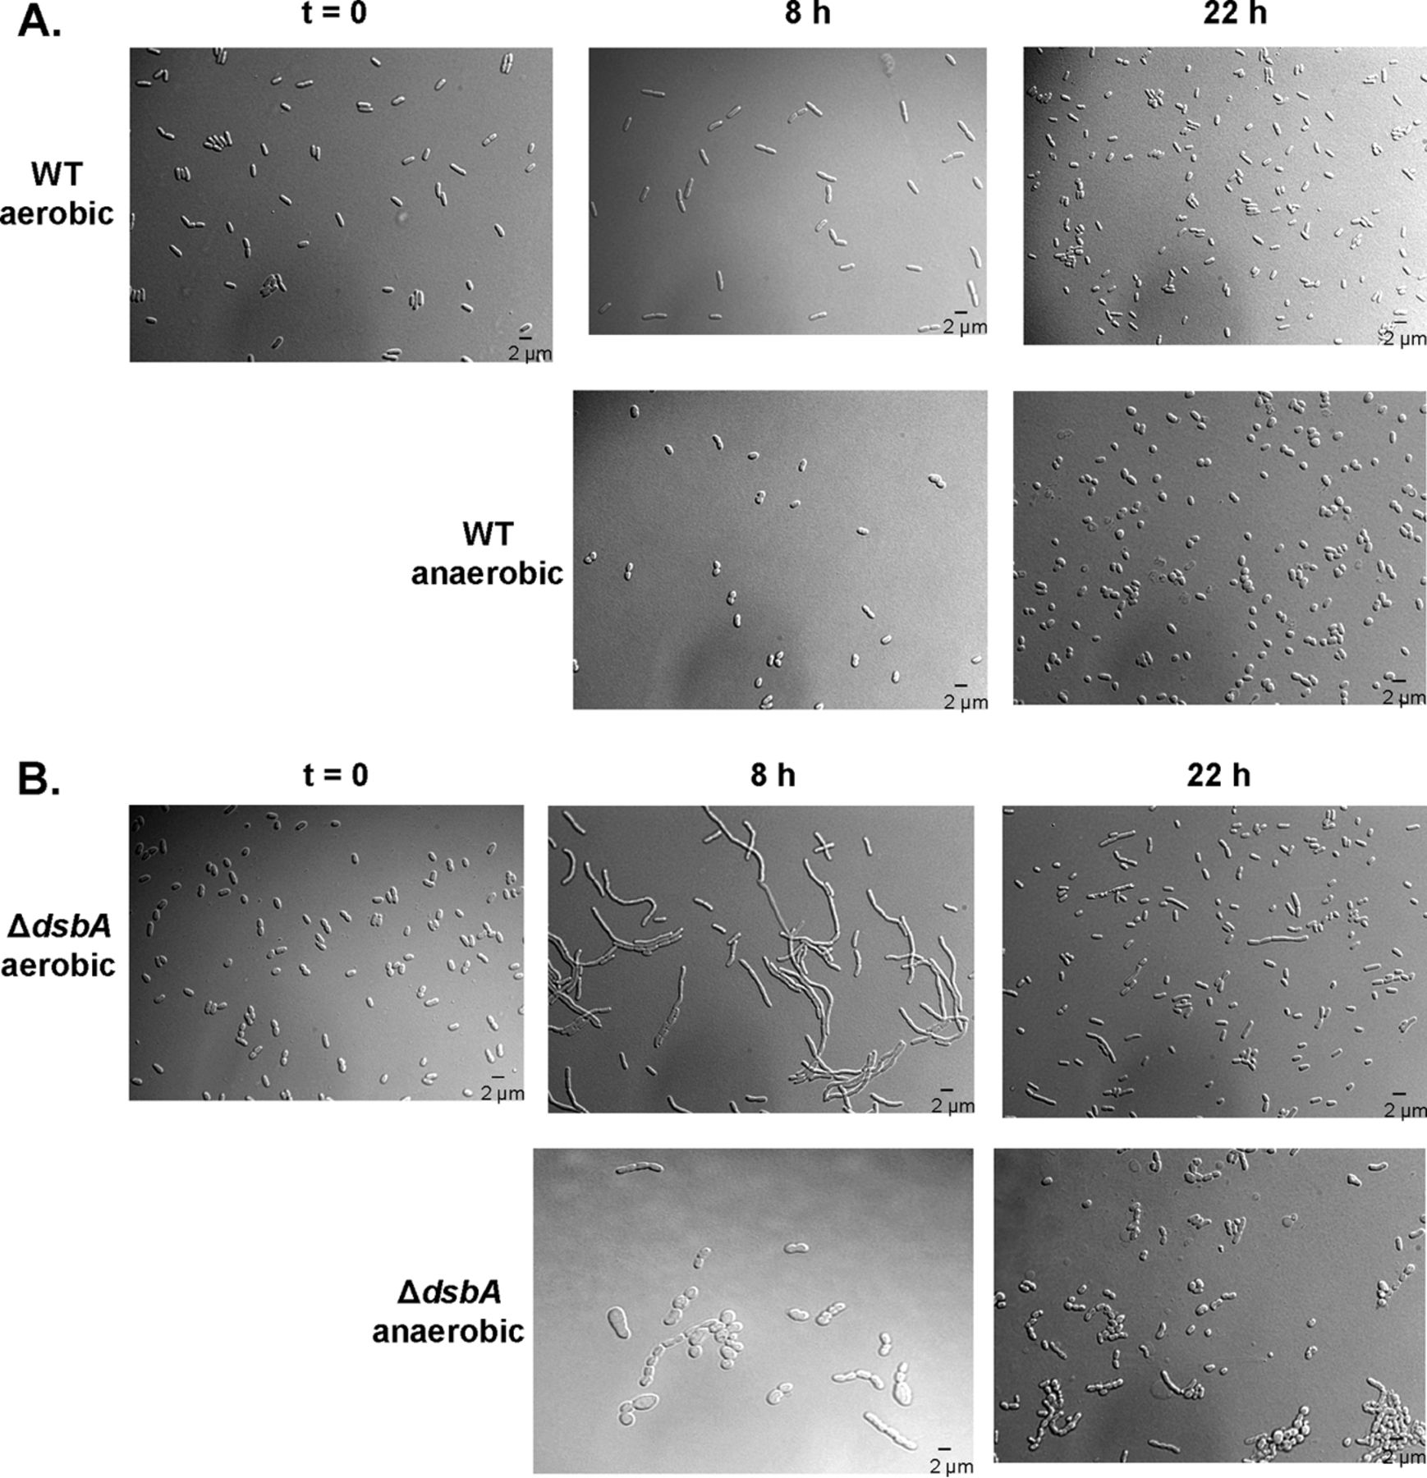
FIG 2 dsb mutants display gross morphological changes. Wild-type (HK295) (A) and ΔdsbA mutant (HK317) (B) strains were grown aerobically in M63glu at 37°C to log phase and then diluted 1:1,000 into M63glu aerobically or M63glu with 40 mM nitrate anaerobically (t = 0). Samples were taken over time, and cells were concentrated via centrifugation. Aliquots were applied to agarose pads affixed to microscope slides and visualized with DIC microscopy. [Reproduced from Meehan et al]

Exercise C.

Look at your thesis thus far (or any other piece of writing). Go through it, and examine your narrative/whether you have described experiments in a logical order. Consider how your writing can be improved and make the appropriate edits.

References
- Tschowri N, Schumacher MA, Schlimpert S, et al. Tetrameric c-di-GMP mediates effective transcription factor dimerization to control Streptomyces development. Cell. 2014;158(5):1136-1147.
- Thomason, L. C., & Court, D. L. (2022). Study of Ren, RexA, and RexB Functions Provides Insight Into the Complex Interaction Between Bacteriophage λ and Its Host, Escherichia coli. PHAGE, 3(3), 153–164. https://doi.org/10.1089/phage.2022.0020
- Hajj, S. E., Henry, C., Andrieu, C., Vergnes, A., Loiseau, L., Brasseur, G., Barré, R., Aussel, L., & Ezraty, B. (2022). HprSR Is a Reactive Chlorine Species-Sensing, Two-Component System in Escherichia coli. Journal of Bacteriology, 204(2). https://doi.org/10.1128/jb.00449-21
- Muñoz-Gutierrez, V., Cornejo, F. A., Schmidt, K., Frese, C. K., Halte, M., Erhardt, M., Elsholz, A. K. W., Turgay, K., & Charpentier, E. (2024). Bacillus subtilis remains translationally active after CRISPRi-mediated replication initiation arrest. mSystems, 9(4). https://doi.org/10.1128/msystems.00221-24
- Meehan BM, Landeta C, Boyd D, Beckwith J. The Disulfide Bond Formation Pathway Is Essential for Anaerobic Growth of Escherichia coli. J Bacteriol. 2017;199(16):e00120-17. Published 2017 Jul 25. doi:10.1128/JB.00120-17

