Writing exercise S08: Model Figures

Dr. Morgan Feeney, AY 2024-25

Model figures can help to clarify complicated concepts and using them in your thesis can be very helpful: they help to make sure your reader “is on the same page” as you and has the same understanding of your system/topic. They can also be quite helpful in terms of word count – a picture is worth a thousand words, after all!
However, consider the figure below (or any textbook figure showing the functioning of the Escherichia coli lac operon.

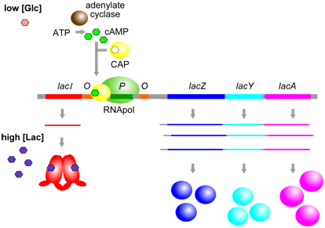
Figure 12.1.612.1.6: When glucose [Glc] and lactose [Lac] are both high, the lac operon is transcribed at a moderate level, because CAP (in the absence of cAMP) is unable to bind to its corresponding cis-element (yellow) and therefore cannot help to stabilize binding of RNApol at the promoter. Alternatively, when [Glc] is low, and [Lac] is high, CAP and cAMP can bind near the promoter and increase further the transcription of the lac operon. (Origianl-Deyholos-CC:AN) [From: Biology LibreTexts]

Exercise A.
Analyse the figure and ask yourself:
- What is the figure showing?
- What is wrong with it?
- How can it be improved?

Consider also the four model figures shown below: although they all depict the same regulatory system, they are remarkably different (because of the increased understanding of the system and/or because the authors of the different papers were choosing to focus on different aspects of the system.)

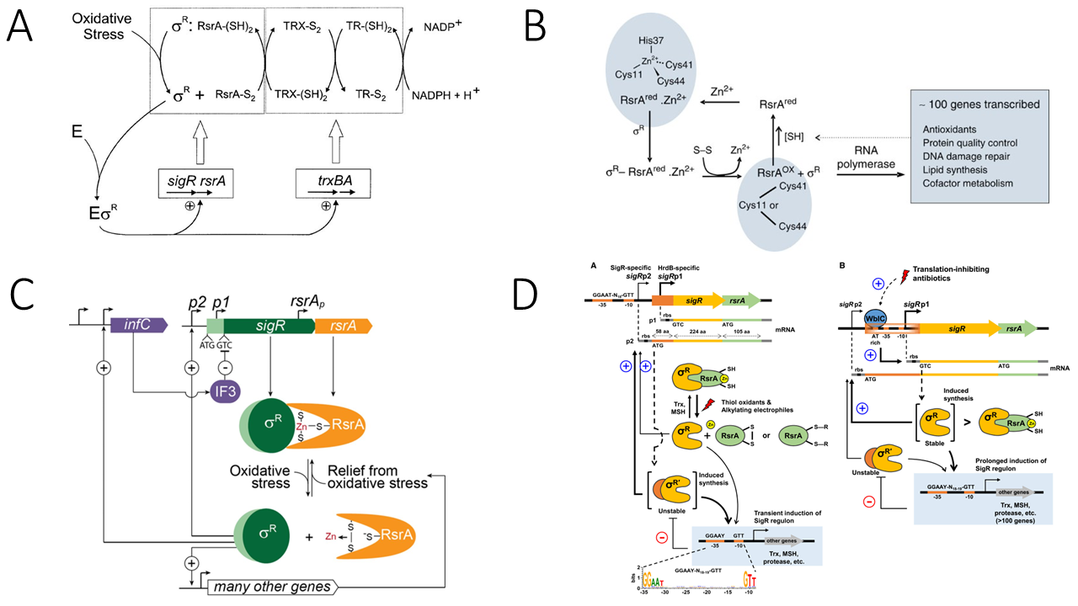
Figure 2. Models of the SigR-RsrA system from Streptomyces. Reproduced from A) Kang et al 1999, B) Rajasekar et al 2016, C) Feeney et al 2017, D) Park et al 2019.

Discussion Questions
- Which figure do you prefer, and why?

- What are the positives and negatives of each? In which context would you choose to use each of them?

- How might these figures be improved/how else might you illustrate this system?

Exercise B.

Draw a model figure illustrating the system you are working on in your project. (You may wish to create two versions – one for your written thesis and one for your presentation.)
Consider this model figure critically: does it contain everything your reader (or audience) needs to know to understand the system? Does it contain anything extraneous/irrelevant to the point you wish to make? How can it be improved?

References
Kang JG, Paget MS, Seok YJ, et al. RsrA, an anti-sigma factor regulated by redox change. EMBO J. 1999;18(15):4292-4298. doi:10.1093/emboj/18.15.4292
Rajasekar KV, Zdanowski K, Yan J, et al. The anti-sigma factor RsrA responds to oxidative stress by reburying its hydrophobic core. Nat Commun. 2016;7:12194. Published 2016 Jul 19. doi:10.1038/ncomms12194
Feeney MA, Chandra G, Findlay KC, Paget MSB, Buttner MJ. Translational Control of the SigR-Directed Oxidative Stress Response in Streptomyces via IF3-Mediated Repression of a Noncanonical GTC Start Codon. mBio. 2017;8(3):e00815-17. Published 2017 Jun 13. doi:10.1128/mBio.00815-17
Park JH, Lee JH, Roe JH. SigR, a hub of multilayered regulation of redox and antibiotic stress responses. Mol Microbiol. 2019;112(2):420-431. doi:10.1111/mmi.14341

