Writing exercise S04: Structuring your introduction/outlining

Dr. Morgan Feeney, AY 2024-25

Your introduction should:
- Start broad (“In all domains of life…”) and narrow down to your topic of interest
- Give all necessary background information your reader will need
  - Edit later if necessary (e.g. if you realise the reader will need more information about some particular topic)
- End with your hypothesis and aims. You should make it clear why you are doing your particular experiment (how you are addressing a knowledge gap in the field). The reader should be led to understand how your experiment is the best and most logical experiment to do next to further our understanding of the subject.
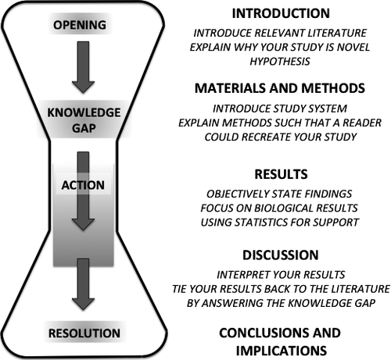
Figure 1. Structure of a scientific paper. Reproduced from Turbek et al (2016) Scientific Writing Made Easy: A Step‐by‐Step Guide to Undergraduate Writing in the Biological Sciences

Exercise
Read the introduction from the following paper and work backwards to generate an outline of key points.
How do the authors guide the reader to understand the previous literature and the context for their hypothesis?
Bilyk B, Kim S, Fazal A, Baker TA, Seipke RF.2020.Regulation of Antimycin Biosynthesis Is Controlled by the ClpXP Protease. mSphere5:10.1128/msphere.00144-20.https://doi.org/10.1128/msphere.00144-20

