Writing exercise S07: Figure legends

Dr. Morgan Feeney, AY 2024-25

A figure legend should allow you to understand the contents of the figure without having to refer to the rest of the text. At the same time, it should be concise (more detailed explanation of the methods and results should be found in the appropriate sections). Writing a good figure legend is an art.

Exercise A.
Read each sample figure legend and ask yourself 3 questions:
- Do you understand what the figure is presenting (without having to read any additional text)?
- Why (or why not?)
- How can it be improved?

Example 1¹.

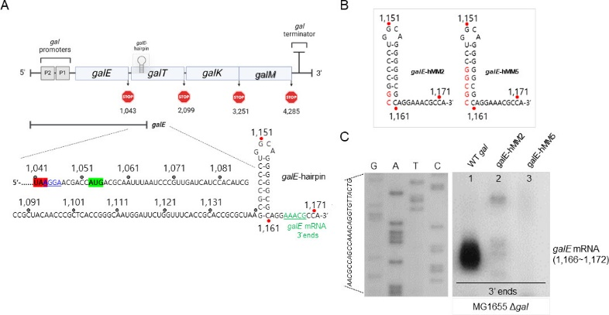
Fig 1 A hairpin structure, galE hairpin, is responsible for the functioning of the 3′ end of galE mRNA as an exo-block. (A) Galactose operon (top) and nucleotide sequence (bottom) of the 3′ end of galE mRNA (green) in the WT gal operon. The galE stop codon is highlighted in red, and the galT initiator codon and SD sequence are highlighted in green and blue (underlined), respectively. The galE hairpin structure is depicted based on base complementarity between positions 1142 and 1161. Numbers indicate the nucleotide residue coordinate of the gal operon, which starts from the transcription initiation site of the galP1 promoter. (B) Schematics of galE-hMM2 and galE-hMM5 mutants. The base changes are in red. The gal mutants were generated in the single-copy plasmid, pGal, where the entire gal operon is cloned and assayed in MG1655 cells from where the entire gal has been removed, MG1655Δgal. (C) 3′ RACE assay of galE mRNA 3′ ends from MG155 cells harboring the plasmid-borne galE-hMM2 and galE-hMM5 mutant operons. The galE mRNA 3′ ends (1166–1172) are missing in lanes 2 and 3. DNA sequencing ladders that serve as length markers are in lanes marked G, A, T, and C.

Example 2².
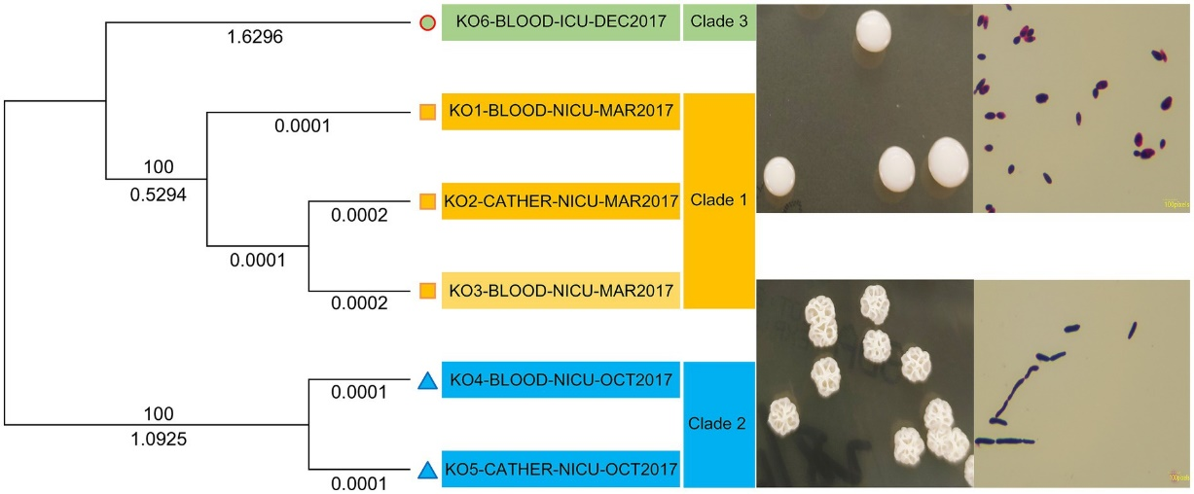
Figure 2. Phylogenetic analysis of six Kodamaea ohmeri strains based on core genome SNPs.

Example 3³.
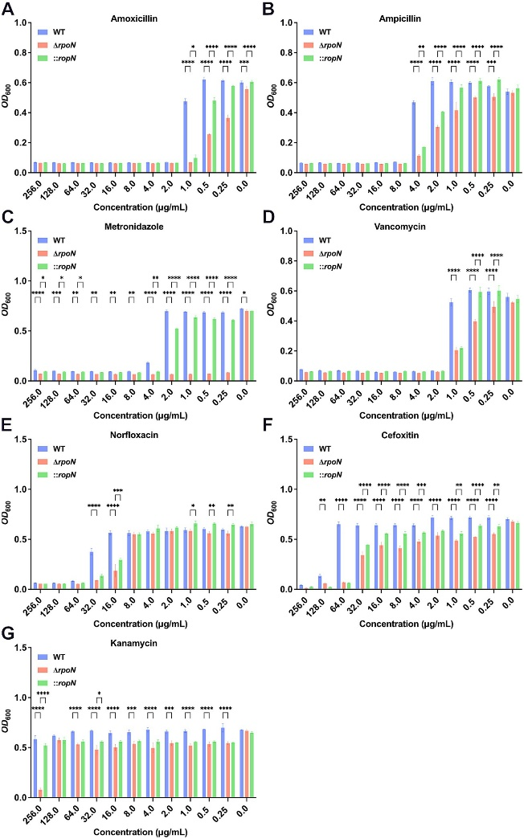
Figure 3. Antibiotic susceptibility of WT, ∆rpoN, and ⸬rpoN strains. The vertical axis represents the OD₆₀₀ value, while the horizontal axis represents the concentration of different antibiotics (mg/mL). The blue, red, and green bars indicate the OD₆₀₀ values of WT, ΔrpoN, and ⸬rpoN strains at different antibiotic concentrations. Compared to WT, the ΔrpoN strain exhibited significantly decreased susceptibility to amoxicillin (A), ampicillin (B), metronidazole (C), vancomycin (D), norfloxacin (E), cefotetan (F), and kanamycin (G), whereas the ⸬rpoN strain showed partial restoration of susceptibility to these antibiotics compared to WT.

Exercise B.

Write a legend for the following figure. Compare your legend with the authors’⁴.

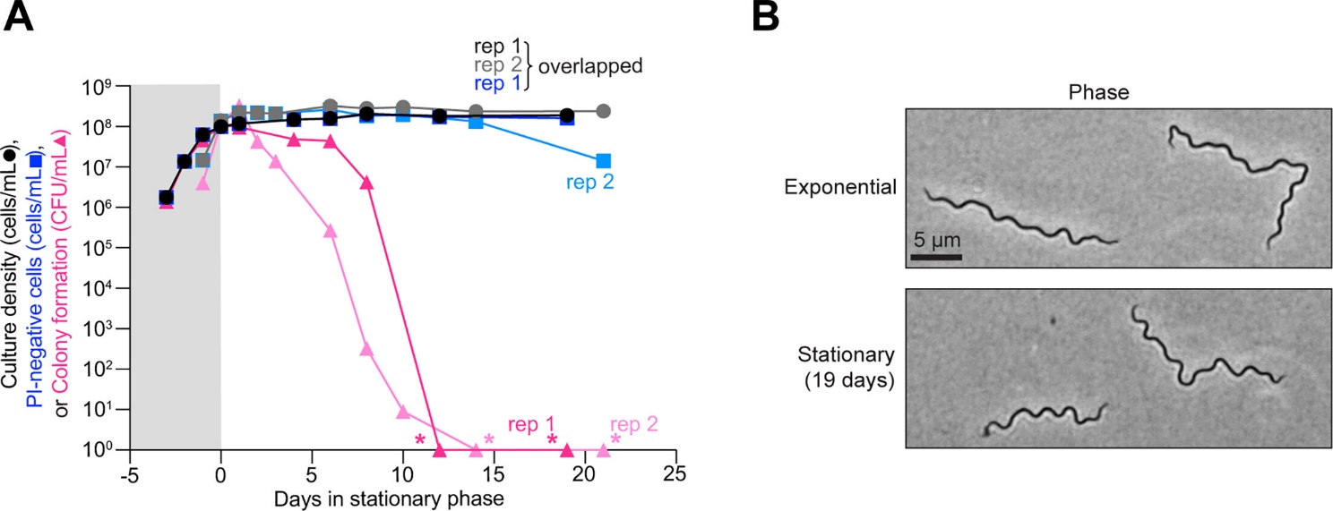

References
- Jeon HJ, et al. Rho-dependent termination and RNase E-mediated cleavage: dual pathways for RNA 3′ end processing in polycistronic mRNA. Journal of Bacteriology 207, e00437-24 (2025).https://doi.org/10.1128/jb.00437-24
- Wang, S.-J., Yu, X., Liang, J.-h., Zheng, D.-y. & Cao, C.-W. Emerging pathogens: the underestimated risk of Kodamaea ohmeri infection in hospitals. Frontiers in Microbiology Volume 16 - 2025 (2025). https://doi.org/10.3389/fmicb.2025.1572747
- Yang, Y. et al. The sigma factor σ54 (rpoN) functions as a global regulator of antibiotic resistance, motility, metabolism, and virulence in Clostridioides difficile. Frontiers in Microbiology Volume 16 - 2025 (2025). https://doi.org/10.3389/fmicb.2025.1569627
- Zhang, J. et al. Borrelia burgdorferi loses essential genetic elements and cell proliferative potential during stationary phase in culture but not in the tick vector. Journal of Bacteriology 207, e00457-00424 (2025). https://doi.org/doi:10.1128/jb.00457-24

